Literature Background Outline

John Robinson

CSC-498-01

Introduction:

* Implementation of Facial Recognition AI using a CNN
* A deep dive into Efficient Facial Expression Recognition, Deep learning-based image recognition for autonomous driving,

Topic 1: Covering ANN

“ANNs are processing devices (algorithms or actual hardware) that are loosely modeled after the neuronal structure of the mamalian cerebral cortex but on much smaller scales”(shipyard)

Topic 2: Covering CNN

* Reviewing CNN step by step to show full understanding and stable foundation of image recognition.
* What is a CNN

“When a computer sees an image (takes an image as input), it will see an array of pixel values. Depending on the resolution and size of the image, it will see a 32 x 32 x 3 array of numbers.”(Adit Deshpande)

”ConvNets derive their name from the “convolution” operator. The primary purpose of Convolution in case of a ConvNet is to extract features from the input image. Convolution preserves the spatial relationship between pixels by learning image features using small squares of input data”(ujjwalkarn)

“When a computer sees an image (takes an image as input), it will see an array of pixel values. Depending on the resolution and size of the image, it will see a 32 x 32 x 3 array of numbers.”(Adit Deshpande)

“This helps the CNN stay mathematically healthy by keeping learned values from getting stuck near 0 or blowing up toward infinity”(e2eML school)

This layer basically takes an input volume (whatever the output is of the conv or ReLU or pool layer preceding it) and outputs an N dimensional vector where N is the number of classes that the program has to choose from. For example, if you wanted a digit classification program, N would be 10 since there are 10 digits. Each number in this N dimensional vector represents the probability of a certain class”(Adit Deshpande).

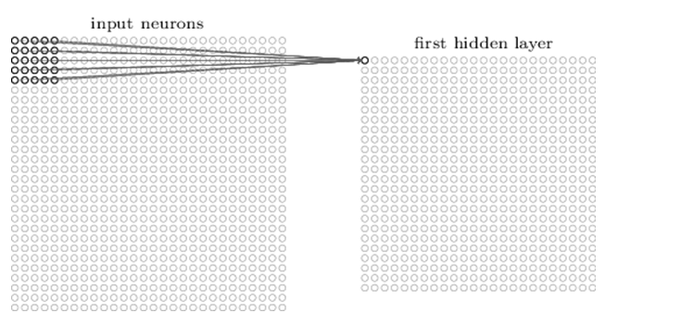

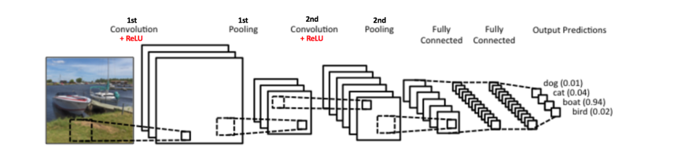

Topic 3: Reviewing applications of CNN to facial recognition along with potential downfalls/weaknesses and ways to make up for them

* Ti-pooling

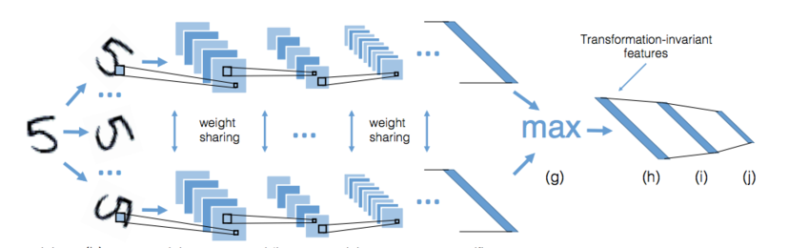

* Siamese networks

they lack a very important property of incorporating any prior information [ 6 ]. When applied to expression analysis, it seems insufficient to well describe expressional images as variations such as identities add redundant noises to these features.”(Siyue Xie)

“images from the same transformation set are set as the inputs of identical parallel channels. Then, each image passes through the convolutional module and yields a concatenate feature vector. Weight sharing is implemented among all the channels. TI-pooling is implemented across all these channels”(Siyue Xie).

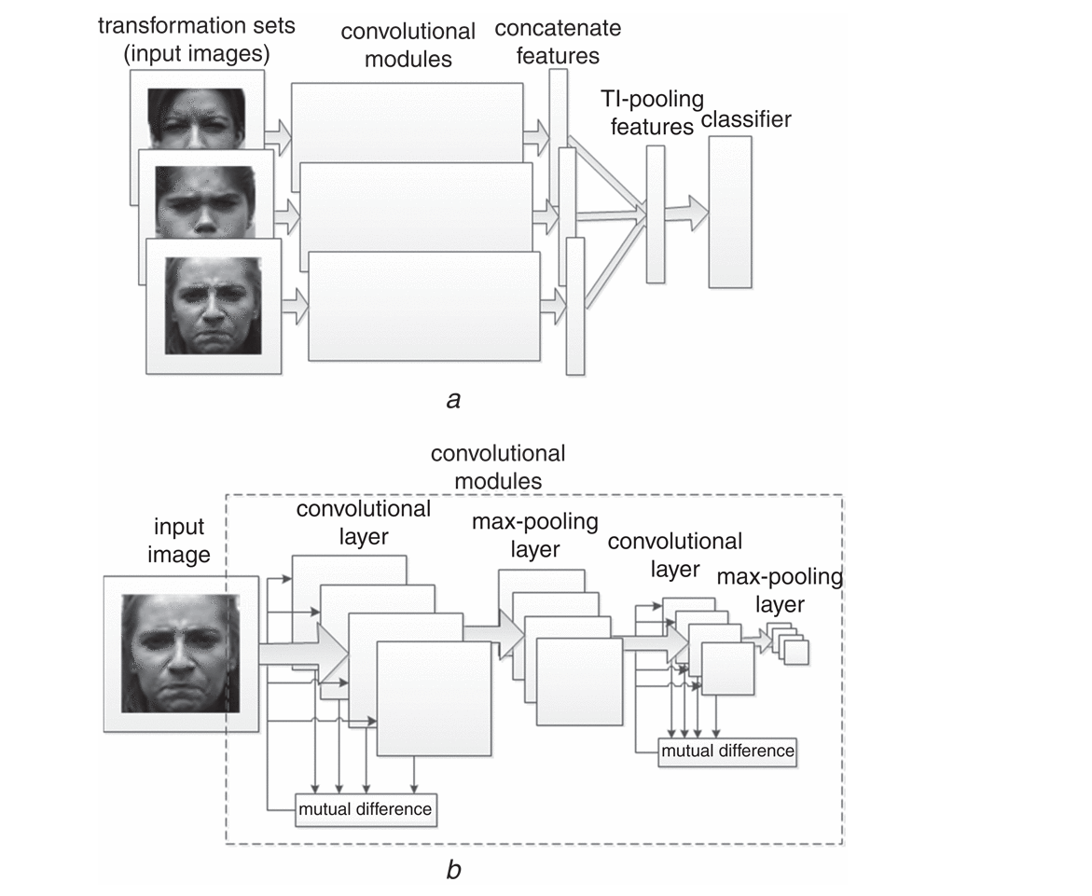

* gCNN

“captures the movements of the landmarks of emotion. The feature of the partial elements obtained by detecting the movement of the landmark is added to the overall features so that more robust features can be extracted”(JI-HAE KIM)

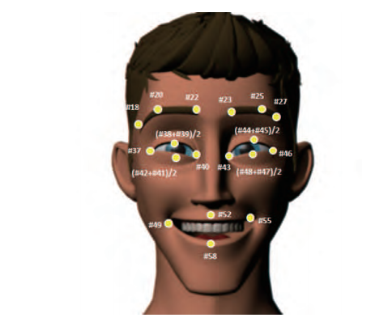

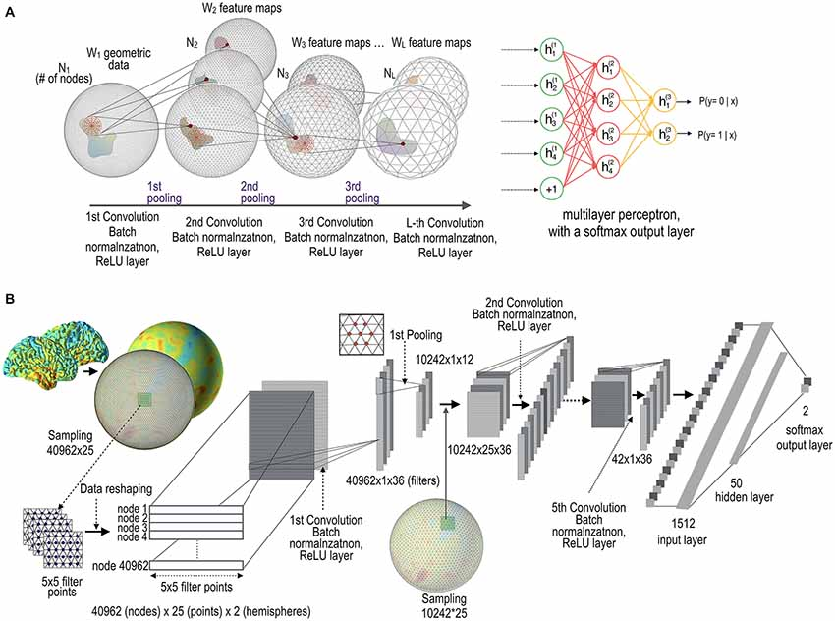

Conclusion:

Bibliography:

<https://www.hindawi.com/journals/aans/2011/673016/>

<https://www.nature.com/articles/s41746-018-0040-6>

<https://jivp-eurasipjournals.springeropen.com/articles/10.1186/s13640-019-0417-8>

<https://arxiv.org/ftp/arxiv/papers/2003/2003.05037.pdf>

<https://ieeexplore.ieee.org/stamp/stamp.jsp?tp=&arnumber=8673885>

<https://www.sciencedirect.com/science/article/pii/S1877050921000521>

<https://www.sciencedirect.com/science/article/pii/S0386111219301566>

<https://www.sciencedirect.com/topics/earth-and-planetary-sciences/artificial-neural-network>

<http://pages.cs.wisc.edu/~bolo/shipyard/neural/local.html>

<http://citeseerx.ist.psu.edu/viewdoc/download?doi=10.1.1.440.5963&rep=rep1&type=pdf>

<http://www.cs.toronto.edu/~gkoch/files/msc-thesis.pdf>

<https://adeshpande3.github.io/A-Beginner%27s-Guide-To-Understanding-Convolutional-Neural-Networks/>

<https://ujjwalkarn.me/2016/08/11/intuitive-explanation-convnets/>

<https://e2eml.school/how_convolutional_neural_networks_work.html>

<http://pages.cs.wisc.edu/~bolo/shipyard/neural/local.html>

Shipyard

<https://digital-library.theiet.org/content/journals/10.1049/el.2016.4328>

Siyue Xie 1

<https://arxiv.org/abs/1604.06318>

Tipool

<https://github.com/dlaptev/TI-pooling#:~:text=TI%2Dpooling%20is%20a%20simple,(CNN)%20transformation%2Dinvariant>.

Tipool

<https://digital-library.theiet.org/content/journals/10.1049/el.2016.4328#C6>

Siyue Xie

<https://www.frontiersin.org/articles/10.3389/fninf.2018.00042/full>

Si-Baek Seong, Chongwon Pae, and Hae-Jeong Park